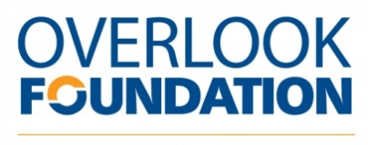

Grant Progress Report

- Name of Organization:

- Name of funded program/project and date funding received:

- What were the objectives of the project and were they accomplished?

    - Please explain any discrepancies and/or obstacles in achieving the objectives.

    - What metrics did you use to measure success?

    - Provide a brief budget summary

- What was the total number of people served by the program? To the best of your ability, please
provide a breakdown by their town of residence in Overlook’s primary service area which includes
- Berkeley Heights
- Chatham
- Cranford
- Millburn/Short Hills
- Mountainside
- New Providence
- Scotch Plains/Fanwood
- Springfield
- Summit
- Union/Vauxhall
- Westfield
- Other bordering towns that benefited the Overlook community.

- Will you continue the project in the future? If so, describe your plan for the program to be
self-sustaining.

- Please describe in a few sentences how one or more individuals benefited because of this Overlook Foundation grant. It should be an anecdotal account showing progress or growth. If you are submitting photos please ensure written permission has been received for the Overlook Foundation to use them.

Do we have your permission to use this information and/or pictures? Yes No

- Progress reports are due within one (1) year of receiving grant funds.

Person submitting this progress report

Name Title Date
Address (if different from the organization)

Phone Email

In submitting this progress report, I certify that the information I have provided is accurate and
complete to the best of my knowledge and that I have full authorization to submit this report of behalf of the organization.

To submit this report, please email it to overlookgrants@atlantichealth.org

